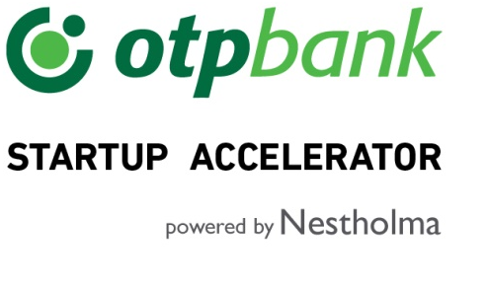
We are looking for startups for our OTP startup accelerator. An intensive three-month program for startups to pursue new business opportunities and grow their network with OTP Bank.
Apply now at f6s.com/otpstartupaccelerator2018 or learn more at nestholma.com/fintech/otp-accelerator

Alternatively, insert button to apply, copying the following code:
<a id="f6s-apply-59ea09f6b0016" href="https://www.f6s.com/otpstartupaccelerator2018" title="Apply to OTP Startup Accelerator 2018 on https://www.f6s.com/">Apply</a><script type="text/javascript">var F6S_v1 = F6S_v1 || {}; F6S_v1.params = F6S_v1.params || []; F6S_v1.params.push({ type: 'widget', widgetType: 'apply-countdown-button', containerId: 'f6s-apply-59ea09f6b0016' });(function() { var st = document.createElement('script'); st.type = 'text/javascript'; st.async = true; st.src = 'https://www.f6s.com/system/js/widgets'; var ft = document.getElementsByTagName('script')[0]; ft.parentNode.insertBefore(st, ft); })();</script>

